ESG in Practice

Addressing ESG-related concerns helps us to move forward to playing an active role in implementing ESG. The best way to describe your role in ESG is that you are part of systems, and your role is crucial to the success of that system.
Jack and James work at two supermarkets with very different values and working styles.
Let’s explore the consequences of applying ESG in different ways by looking at the two supermarkets where Jack and James work.
A Day in the Life of Jack and James
Having issues reviewing the interactive graphic? Access an accessible version of A Day in the Life of Jack.
A Day in the Life of Jack
Jack gets up at 8am
The sun is already up, but Jack switches all the lights on and goes to the bathroom to turn the hot water on and to have a bath. While the water is running, he goes to the kitchen to prepare his breakfast.
Jack walks to the kitchen…
He opens the fridge, receives a phone call and goes to the living room to turn the TV on (while the fridge door remains open and the water in the toilet is running). He sits for 10 minutes on the sofa to speak on the phone and watch the news. All the lights in the flat are switched on.
Jack prepares his breakfast
He picks something from the fridge, then he eventually closes the fridge door. He places the bread in his old toaster and remembers that the water in the toilet is still running. When he enters the toilet, it’s all steam and heat. He opens the window to let the steam out.
Jack returns to the kitchen
When he goes back to the kitchen, it’s already filled with the smell of burnt bread and he opens the window to let the smell out (while the toilet and kitchen windows are open, and lights are still on).
Jack heads to the supermarket
When he gets to the supermarket, he finds his colleagues chatting about a new measure whereby supermarkets should eliminate food waste. Jack heads to the large warehouses, checks the wasted food and delivers it to a truck carrying wasted food and delivers it to a truck carrying waste to a landfill, without even questioning it. He then checks that all single-use packaged fruits and vegetables are displayed properly and that there are enough plastic bags available.
The finance manager advises Jack
Meanwhile, the finance manager advises that the carbon footprint tax is getting higher and that something should be done. Jack knows that the food waste tax will soon be a reality for him as well, but he thinks it has nothing to do with his role. He’s also more worried about his personal finance, as his home energy is going really up.

This sounds like an average supermarket, right?
Let’s see James' day. Having issues reviewing the interactive graphic? Access an accessible version of A Day in the Life of James.
A Day in the Life of James
James gets up at 8am too
He opens the curtains and lets the natural light in. He has a quick shower and goes to the kitchen to have some breakfast. He opens the fridge, picks some bread, and closes the door without waiting for the engine to start.
James eats breakfast
He has his breakfast then washes his plate in a sink with a bucket where he collects water for his flowers. He then picks up the plastic waste and heads to work.
James gets to the supermarket
It’s celebration day at James’ supermarket: they have been awarded the prize of grocery store of the year. In the last few years, James and his team have been responsible for implementing some measures against food waste and excessive plastic waste in product packaging.
Reducing food waste at the supermarket
To reduce food waste, they have been cooperating with charities to donate some of their food surpluses and have implanted composting facilities in the supermarket’s area. They have been cooperating with compost experts to create and sell compost, as well as creating composting classes for kids.
How did James’ team get the prize?
As a store manager, James eliminated the need for a large warehouse and the risk of food surplus by changing suppliers and having fresh produce delivered from local farmers. In terms of plastic waste, the team has opted for suppliers who care about sustainable packaging - in the grocery section, for instance, there is no single-use packaging for fresh fruit and vegetables. James’ team has been encouraging customers to use their own containers or compostable bags.

ESG and the Power of Collaboration
Jack's and James' story shows the interconnectedness and shared responsibility we all have in implementing ESG initiatives to drive positive change.
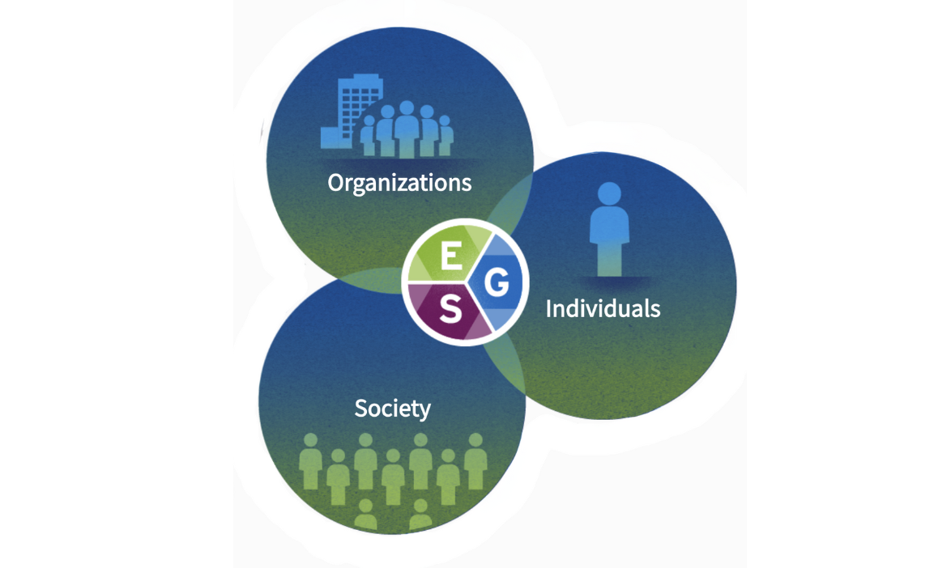
- Organizations: Organizations play a pivotal role in ESG by adopting sustainable practices, driving responsible governance, and making positive social and environmental impacts.
- Individuals: By adopting sustainable practices, making responsible choices, and supporting the organisation's ESG initiatives, individuals can inspire others to follow suit.
- Society: Governments of the world, organizations, and communities need to work together to address issues like climate change, social inequality, and responsible governance by standardizing ESG frameworks.
Challenging the Status Quo
Now, read an article describing how Paul Polman promoted sustainable practices at Unilever by challenging the status quo. Under his leadership, Unilever incorporated the United Nations' Sustainable Development Goals into their business model and committed to reducing their environmental footprint. He also pushed for transparency and strove for gender balance in the company's leadership positions.
Read: Unilever's Paul Polman: challenging the corporate status quo (The Guardian)

